**HVS ROLL 70 86 ASPEK**

**BRIGHTNESS 72%**

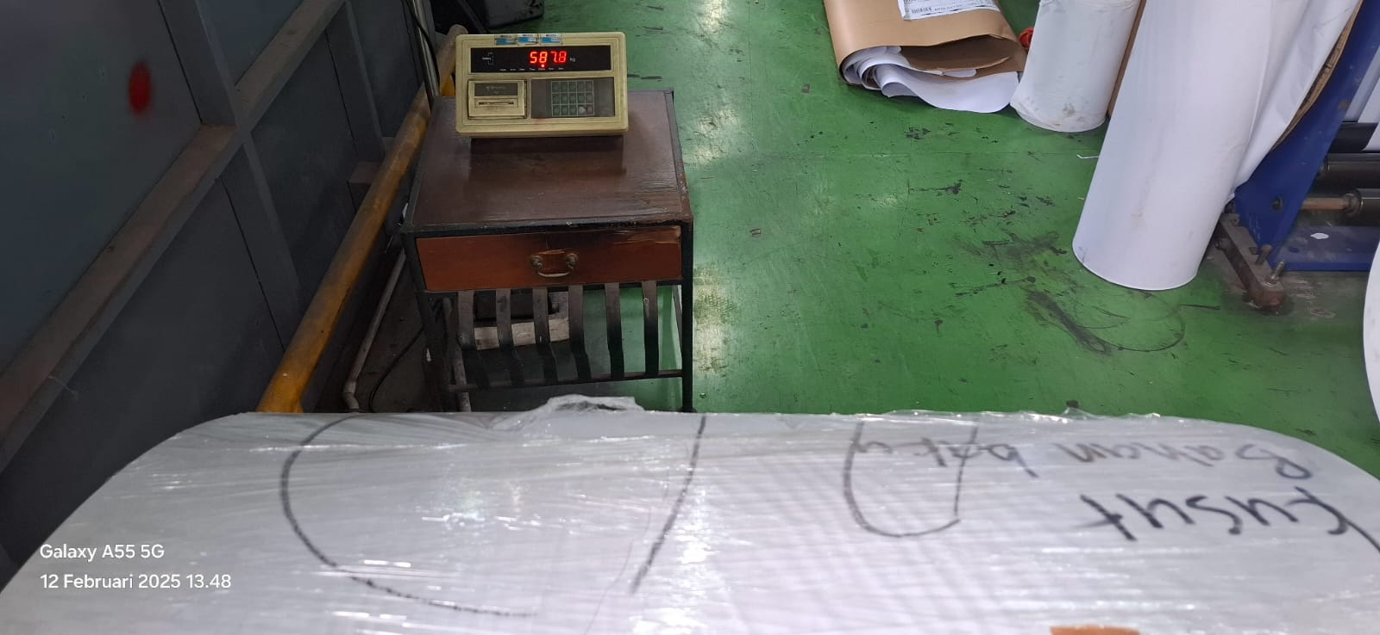

587 kg